食品药化类专业培养计划

一、培养目标、国际认证标准（Objectives、International Certification Standards）：
本专业培养具有良好的人文素质、扎实的食品、药学及化工基本理论、基础知识和实践能力，具备分析、解决复杂问题的能力，能够在药学及食品、化工等相关行业从事研究、技术开发、质量控制、工艺改造、生产组织、管理与服务，成为具备跨岗位适应能力的并具有创新精神、国际化视野以及汉语言优势的国际技术人才；同时兼顾面向国家“一带一路”倡议，培养知华、友华、爱华与建华的具备专业技能的国际人才，能够成为中国与所在国之间的食品、药品及化工企业合作桥梁与纽带的复合型、应用型创新创业实践人才。
This major will culture professionals with good humanistic and social scientific literacy. These professionals will adapt to social and economic development requirement and national food industry development needs. Moreover, these professionals will also have basic theories, knowledge, and skills about natural science, and the ability to study and design new products, processes and technologies. Furthermore, these professionals will meet the requirements of the food industry to knowledge, capabilities and literacy. They will also have the ability to work in food industry and related fields engaging in product development, scientific research, engineering design, production technology management, quality inspection and quality control.

二、毕业要求（Graduation Requirements）：
本专业以食品、药学、化学为主干学科，采取宽口径厚基础人才培养计划，突出兼顾多学科特色，坚持知识、能力、素质和个性协调发展，培养知华、友华、爱华与建华的具备专业技能的国际人才，学生毕业时应达到以下要求：
毕业要求 1-领域知识：能够将数学、自然科学、工程基础和化学、药学、食品专业知识用于解决复杂的食品化学药学领域问题；
毕业要求 2-问题分析：能够应用数学、自然科学和工程基本原理，识别、表达、并通过文献研究分析复杂食品化学药学领域问题，以获得有效结论；
毕业要求 3-设计/开发解决方案：能够针对食品化学药学领域的复杂问题选择适用的工艺或设备，或具备设计满足特定需求的系统、单元（部件）或工艺流程的初步能力，在设计环节中能够体现创新意识，考虑社会、健康、安全、法律、文化以及环境等因素；
毕业要求 4-研究：能够基于科学原理并采用科学方法对食品化学药学领域问题进行研究，包括设计实验、分析与解释数据、并通过信息综合得到合理有效的结论；
毕业要求 5-使用现代工具：能够针对食品化学药学领域相关复杂工程问题，开发、选择与使用恰当的技术、资源、现代工程工具和信息技术工具，包括对复杂工程问题的预测与模拟，并能够理解其适用范围；
毕业要求 6-社会责任：能够基于食品化学药学相关背景知识进行合理分析，评价食品化学药学专业实践问题的解决方案对社会、健康、安全、法律以及文化的影响，并理解应承担的责任；
毕业要求 7-环境和可持续发展：能够理解和评价满足食品化学药学实践中特定的设计和制备工艺对环境、社会可持续发展的影响；
毕业要求 8-职业规范：了解中国文化、历史与国情，且具有人文社会科学素养与社会责任感，能够在食品化学药学领域实践中理解并遵守工程职业道德和规范，履行责任，成为知华、友华、爱华与建华的具备专业技能的国际人才；
毕业要求 9-个人和团队：能够在多学科背景下的团队中承担个体、团队成员以及负责人的角色；
毕业要求 10-沟通：能够就食品化学药学领域问题与业界同行及社会公众进行有效沟通和交流，包括撰写报告和设计文稿、陈述发言、清晰表达或回应指令。具备一定的国际视野，能够在跨文化背景下进行沟通和交流；
毕业要求 11-项目管理：能够在多学科环境中理解并掌握工程管理原理与经济决策方法，具有一定的组织、管理和领导能力；
毕业要求 12-终身学习：具有自主学习和终身学习的意识，有不断学习和适应发展的能力。
- Project knowledge: Graduates will have the ability to use mathematics, natural science, engineering foundation and expertise to address complex food engineering issues.
- Problem Analysis: Graduates will have the ability to use basic principles of mathematics, natural science and engineering science to Identify and analyze complex food engineering issues through literature research and finally obtain effective conclusions.
- Design / develop solutions: Graduates are able to design solutions for complex food engineering problems involving systems, units (components) or processes meeting specific needs. They can also reflect innovative awareness in the design part, considering social, health, safety, legal, cultural and environmental factors.
- Research: Graduates will have the ability to study complex food engineering problems based on scientific principles and scientific methods, including designing experiments, analyzing and interpreting data, and drawing reasonable and effective conclusions through information synthesis.
- Use of modern tools: Graduates will have the ability to develop, select and use appropriate technologies, resources, modern engineering tools and information technology tools to solve complex food engineering problems.
- Engineering & Society: Graduates will have the ability to analyze and evaluate influence of food professional engineering practice and complex food engineering problem solutions on social, health, safety, law and culture. They will also understand the responsibilities that should be undertaken.
- Environment and Sustainable Development: Graduates will understand and evaluate the impact of engineering practice against complex food engineering issues on environmental and social sustainable development.
- Professional norms: Graduates will have humanities and social science literacy, sense of social responsibility, they will also be able to understand and abide by the engineering practice.
- Individual and team: Graduates will be able to play the role of individual, team member and leader in a multidisciplinary team.
- Communication: Graduates will be able to effectively communicate with peers in the industry and the public on complex food engineering issues, including writing reports and design manuscripts, making statements, clearly expressing or responding to instructions. They will also have a certain international vision, and be able to communicate in the cross-cultural background.
- Project Management: Graduates will understand and master the principles of engineering management and economic decision-making methods. They will also be able to apply them in a multidisciplinary environment.
- Lifelong learning: Graduates will have the consciousness of self-learning and lifelong learning, they will also have the ability of continuous learning and adapting to development.

三、涉及学科专业（含学科门类、专业名称、代码）（Majors）：
学科门类：工学 专业名称：食品科学与工程 代码：082701
学科门类：理学 专业名称：药学 代码：100701
学科门类：工学 专业名称：化学工程与工艺 代码：081301
Food Science and Engineering
Pharmacy
Chemical Engineering and Process
四、培养体系和课程模块（Training System and Course Module）：
1. 课程体系
由通识教育课程、学科大类基础课程、专业课程、自主研学选修课程、及实践环节等模块组成（见食品药化类专业课程体系学分分布表）。
主干学科：食品、药学、化学
核心课程：有机化学、生物化学、药物化学、药物分析、药剂学、药理学、分子生物学、生物药剂学与药物动力学、临床药物治疗学、药用高分子材料学、制剂工程学、有机化学、生物化学、微生物学、食品工程原理、食品工艺学、食品化学、食品营养学、现代食品检测技术、食品加工机械与设备、食品工厂设计、无机化学、有机化学、物理化学、过程工程原理、化学反应工程、化工系统工程、化学工艺学、化工仪表与自动化、工程设计与软件运用、化工设备机械基础、安全工程管理、化工热力学、现代分离技术与运用、安全化学汉语
Core courses: Organic Chemistry, Biochemistry, Microbiology, Principle of Food Engineering, Food Processing Technology, Food Chemistry, Food Nutrition, Modern food detection technology, Food processing machinery and equipment, and Food Factory Design.
食品药化类专业课程体系学分分布表
课程类别 | 课程性质 | 药学 | 食品科学与工程 | 化学工程与工艺
通识教育 | 必修 | 55.5 | 55.5 | 55.5
 | 选修 | 4 | 4 | 4
 | 小计 | 59.5 | 59.5 | 59.5
大类基础 | 必修 | 30 | 30 | 30
 | 选修 | 10 | 10 | 10
 | 小计 | 40 | 40 | 40
专业课程 | 必修 | 25 | 17.5 | 20
 | 选修 | 5 | 4 | 9
 | 小计 | 30 | 21.5 | 29
自主研学 | 必修 | 0 | 0 | 0
 | 选修 | 16 | 16 | 16
 | 小计 | 16 | 16 | 16
素质拓展 | 必修 | 6 | 6 | 6
 | 选修 | 0 | 0 | 0
 | 小计 | 6 | 6 | 6
实践环节 | 必修 | 25.5 | 34 | 26.5
 | 选修 | 0 | 0 | 0
 | 小计 | 25.5 | 34 | 26.5
总学分 |  | 177 | 177 | 177

2. 校企合作培养
食品科学与工程专业，已与相关企业建立了校企合作关系，有长期稳定的校外实习基地。实践环节中的相关实习都在实习基地中完成，实习过程由学校带队老师参与，企业专家指导完成，因此，每位学生有接近1年的时间在校外实习和实践。
The major of Food Science and Engineering has established a cooperative relationship with relevant enterprises, and has a long-term and stable internship base outside the school. The relevant internships in the practice link will be completed in the internship base. The practice process is participated by the school leading teachers and guided by the enterprise experts. Therefore, each student will have nearly one year of practice outside school.
五、学制与授予学位（Duration and Degree）：
基本学制四年，弹性学制三至六年，工学学士（食品科学与工程，化学工程与工艺），理学学士（药学）。
Four years of basic education, three to six years of flexible education, Bachelor of Engineering (Food Science and engineering, chemical engineering and Technology), Bachelor of Science (Pharmacy).
六、毕业最低学分（Minimum Required Credits for Graduation）：
四年制专业最低毕业学分为177学分。
The minimum graduation credit of four-year major is 177.
七、课程学分、学时分配表（Distribution Sheet for Credits and Hours）：

课程学分、学时分配表：
课程类别 | 课程性质 | 药学 |  |  | 食品科学与工程 |  |  | 化学工程与工艺
 |  | 学分 | 学时 | 学分占比 | 学分 | 学时 | 学分占比 | 学分 | 学时 | 学分占比
通识教育 | 必修 | 55.5 | 1176 | 31% | 55.5 | 1176 | 31% | 55.5 | 1176 | 31%
 | 选修 | 4 | 96 | 2% | 4 | 96 | 2% | 4 | 96 | 2%
 | 小计 | 59.5 | 1272 | 34% | 59.5 | 1272 | 34% | 59.5 | 1272 | 34%
大类基础 | 必修 | 30 | 560 | 17% | 30 | 560 | 17% | 30 | 560 | 17%
 | 选修 | 10 | 160 | 6% | 10 | 160 | 6% | 10 | 160 | 6%
 | 小计 | 40 | 720 | 23% | 40 | 720 | 23% | 40 | 720 | 23%
专业课程 | 必修 | 25 | 464 | 14% | 17.5 | 288 | 10% | 20 | 362 | 11%
 | 选修 | 5 | 80 | 3% | 4 | 64 | 2% | 9 | 144 | 5%
 | 小计 | 30 | 544 | 17% | 21.5 | 352 | 12% | 29 | 506 | 16%
自主研学 | 必修 | 0 | 0 | 0% | 0 | 0 | 0% | 0 | 0 | 0%
 | 选修 | 16 | 240 | 9% | 16 | 240 | 9% | 16 | 240 | 9%
 | 小计 | 16 | 240 | 9% | 16 | 240 | 9% | 16 | 240 | 9%
素质拓展 | 必修 | 6 | / | 3% | 6 | / | 3% | 6 | / | 3%
 | 选修 | 0 | 0 | 0% | 0 | 0 | 0% | 0 | 0 | 0%
 | 小计 | 6 | / | 3% | 6 | / | 3% | 6 | / | 3%
实践环节 | 必修 | 25.5 | 29.5周 | 14% | 34 | 36周 | 19% | 26.5 | 27周 | 15%
 | 选修 | 0 | 0 | 0% | 0 | 0 | 0% | 0 | 0 | 0%
 | 小计 | 25.5 | 29.5周 | 14% | 34 | 36周 | 19% | 26 | 27周 | 15%
总学分 |  | 177 |  | 100% | 177 |  | 100% | 177 |  | 100%

八、课程体系逻辑关系图
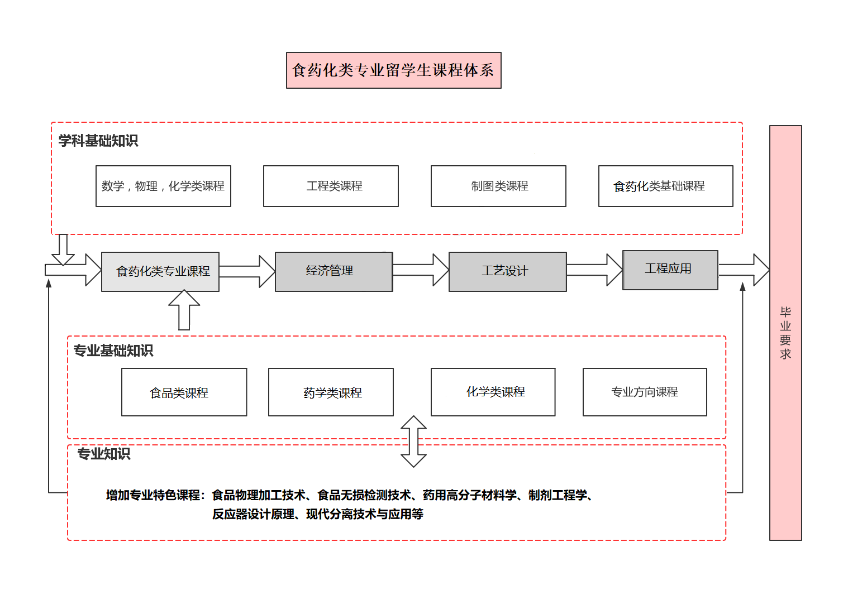
药学专业导学图

食品科学与工程导学图
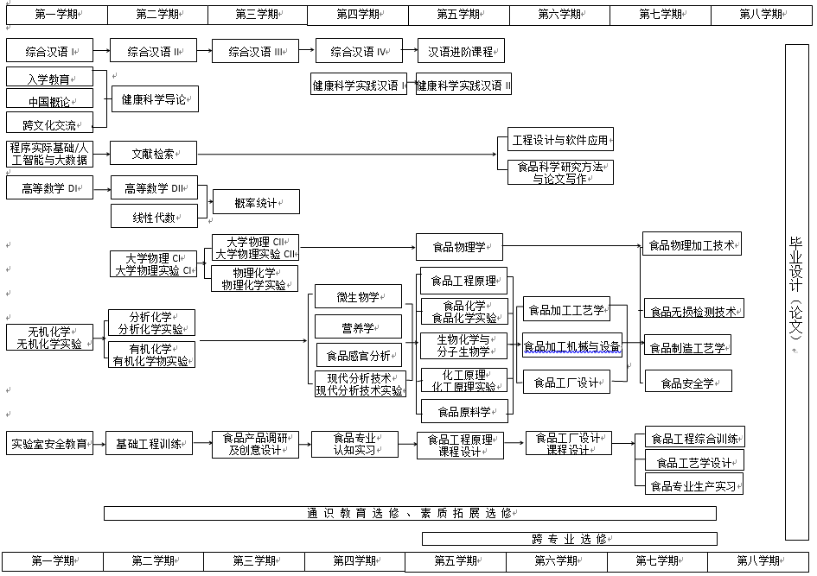
化学工程与工艺导学图
