**2019计算机微专业用户注册和选课步骤指导**

Registration and Course Selection Steps of 2019 Computer Micro-specialty

1. **平台用户注册步骤：**

Registration Steps:

1.登录网址：<http://engedu.ikcest.org/unesco/>

工程教育知识服务系统平台（Engineering Education Knowledge Service）

Website: <http://engedu.ikcest.org/unesco/>

Engineering Education Knowledge Service

1. 首次注册用户请点击首页右上角“sign up”，如下图。

To register for the first time, please click "sign up" in the upper right corner of the home page, as shown below.

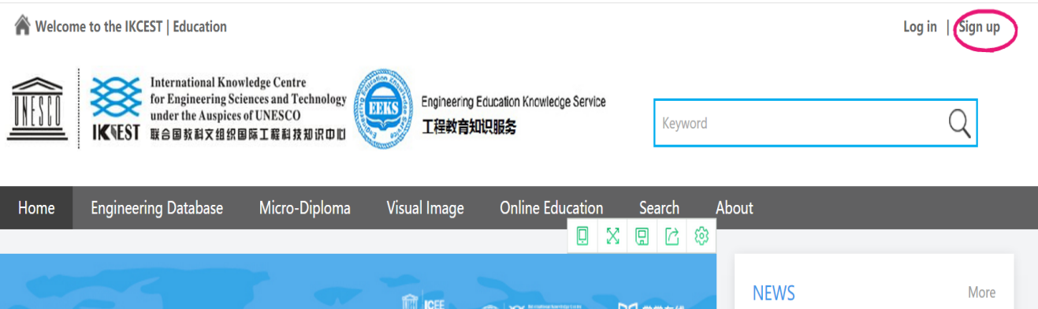

1. 用户输入个人注册信息，请务必牢记个人用户名和登录密码，并确保Email为个人有效邮箱。点击页面最下方“Register”完成注册，如下图。

Users enter personal registration information, and be sure to remember personal user name and login password, and ensure that Email is a valid personal mailbox. Click "Register" at the bottom of the page to complete the registration, as shown below.

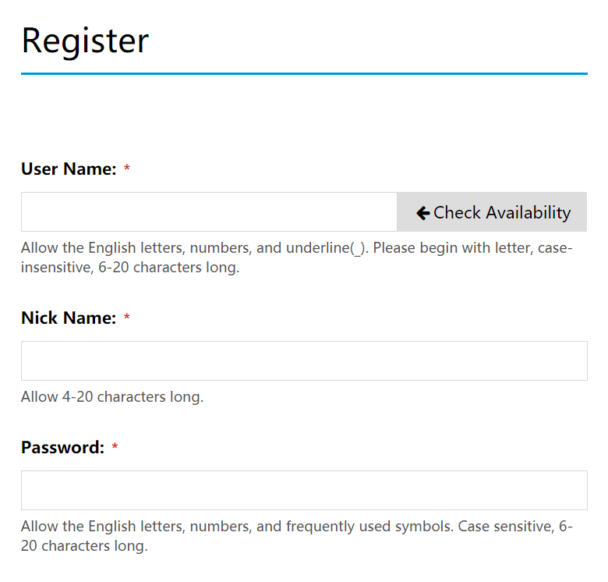

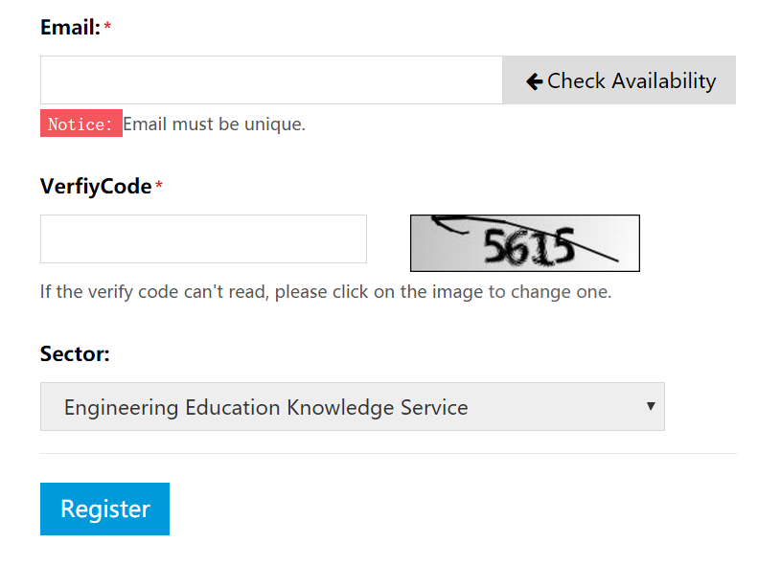

1. 重新登录工程教育知识服务系统平台<http://engedu.ikcest.org/unesco/>首页，点击右上角：“log in”, 输入个人用户名和密码，点击“Submit”即登录成功。

Re-login the home page of Engineering Education Knowledge Service platform http://engedu.ikcest.org/unesco/ ,then click "log in" in the upper right corner, enter the personal user name and password, and click "Submit" to log in successfully.

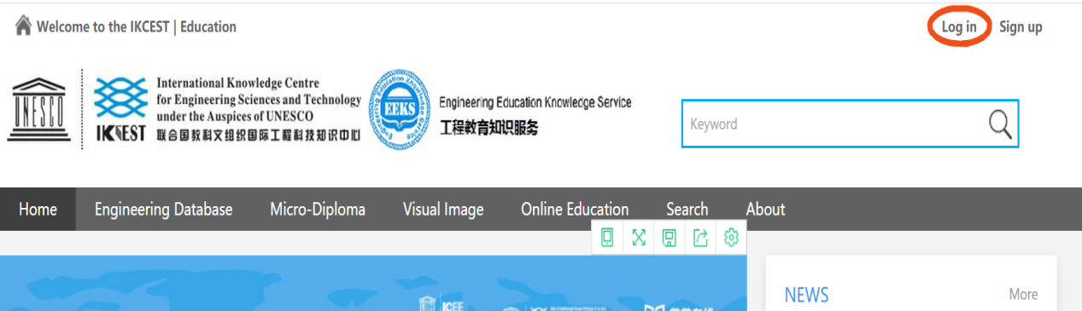

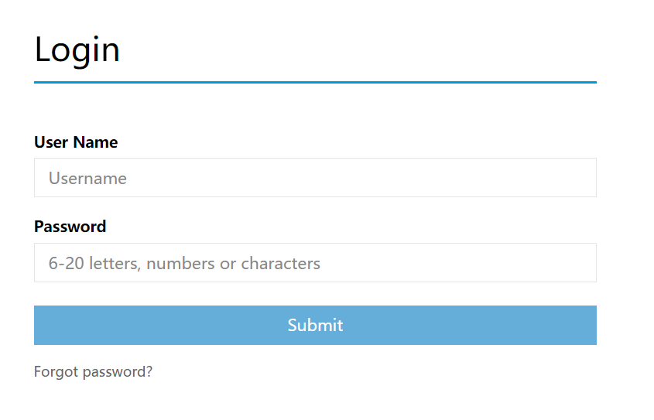

1. **平台用户选课步骤**

Course Selection Steps

1. 以个人用户名登录成功后，点击首页菜单栏“Micro -Diploma”,进入计算机微专业页面，如下图。

After logging in successfully as a personal user, click on the menu bar "Micro-Diploma" to enter the computer micro-specialty home page, as shown below.

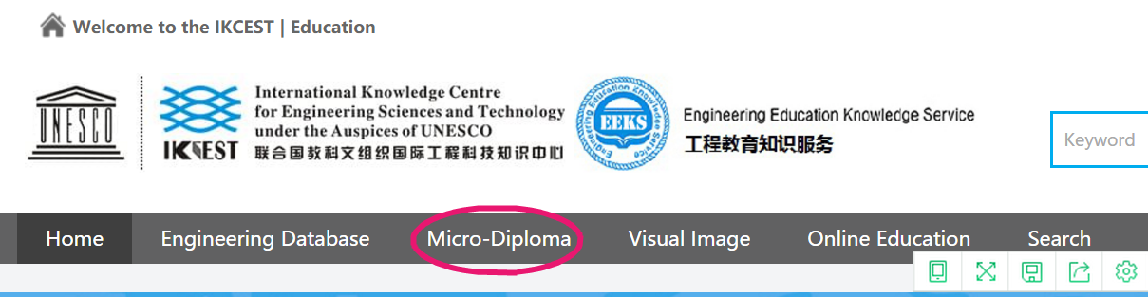

1. 特别提醒注意：下一步点击选择“Micro-Diploma of Computer Science 2019”，如下图。

Note: the next step is to select "Micro-Diploma of Computer Science 2019", as shown below.

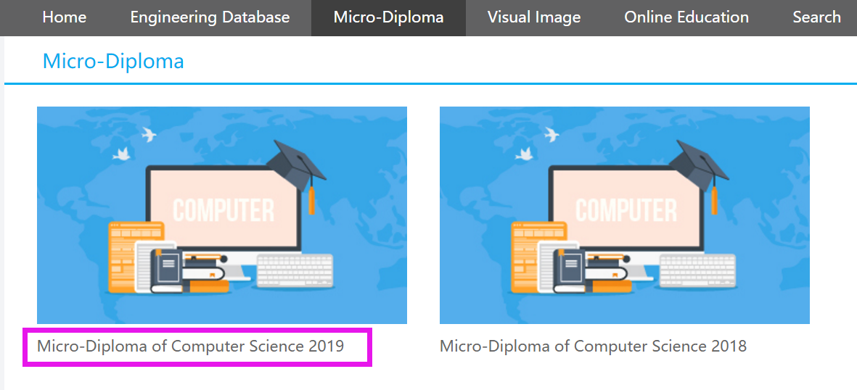

3.下一步看到网页展示出4门2019年计算机微专业MOOC课程，如下图。

The web page will show four MOOC courses of 2019 computer micro-specialty, as shown below.



点击任意一门MOOC, 再点击右下角“我要选课”，学习者即可进行在线学习。

Click on any MOOC course, and click on "I want to choose courses" in the lower right corner and learners will be able to learn online.

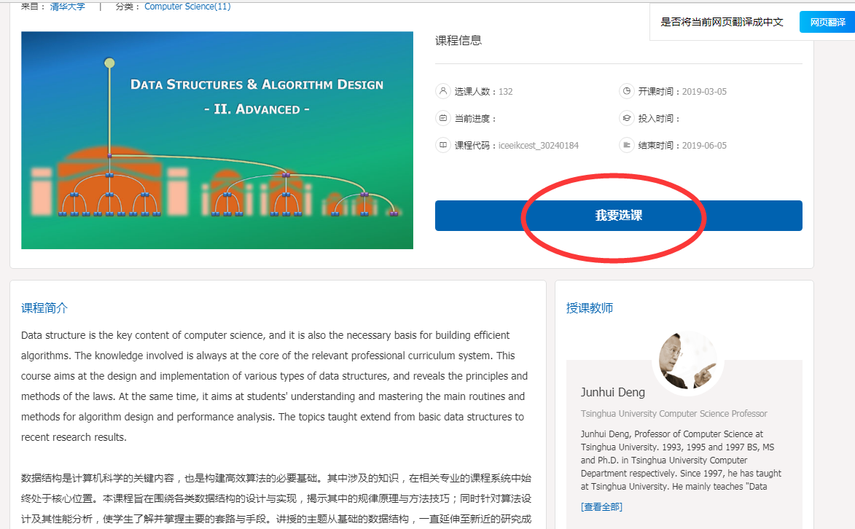

特别提示：在线学习者只有将4门计算机微专业课程线上考试全部通过后，个人才有资格申请获取线上学习结业证书。所以建议希望获取线上学习证书的学员将4门课程全部选修（只通过1门-3门课程考试的学员将无法获取线上结业证书的申请资格）。

Special note: only after passing all online examinations of 4 computer micro-specialty courses, online learners can be eligible to apply for the certificate of completion of online study. Therefore, it is recommended that students who wish to obtain the online certificate of study will take all four courses ( those who only pass the 1-3 course examination will not be eligible for the online Certificate of completion).