1. Make color choice of your own and fill them between the lines
2. Be meditative and mindful when you are coloring: let go of what happened that day
3. The provided pattern is an essential element, other elements can be added to your whole design.
4. Give your artwork a name that you feel connected

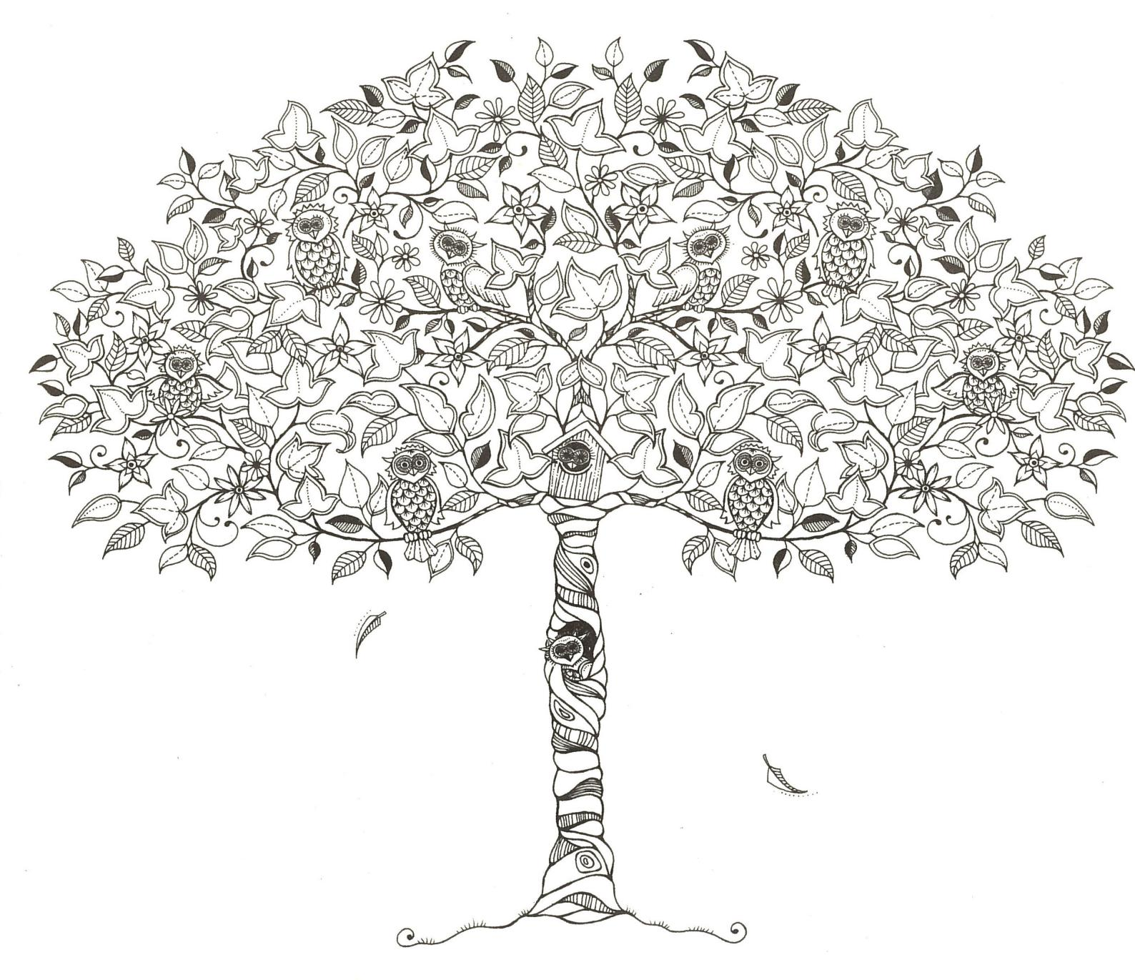

Student Name (in print):_____________________ Student ID Number:___________________

Name of the work:___________________________________________________________________________

Anything you want to share about doing this:______________________________________________________

___________________________________________________________________________________________