How to Pay the Re-learn Fee

1. Log-in the [Academic Management System.](http://oecteaching.ujs.edu.cn/(S(3t5kbfrdpcnz1djmmry3t0bd))/default.aspx)

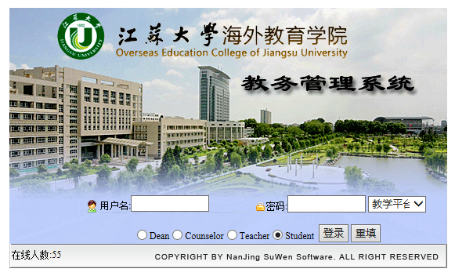

1. Please click the re-learn part.

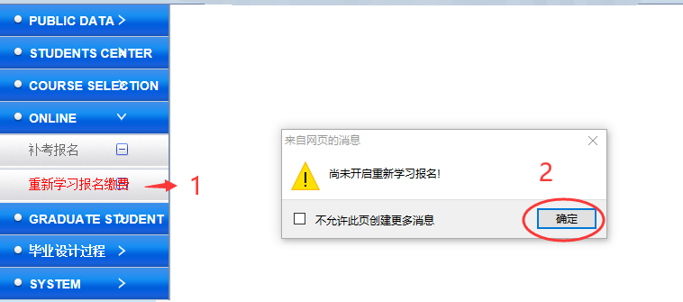

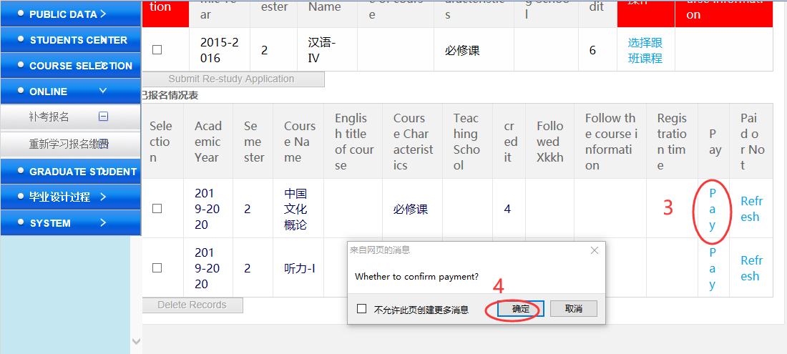

1. Pay the Fee through University Payment System.

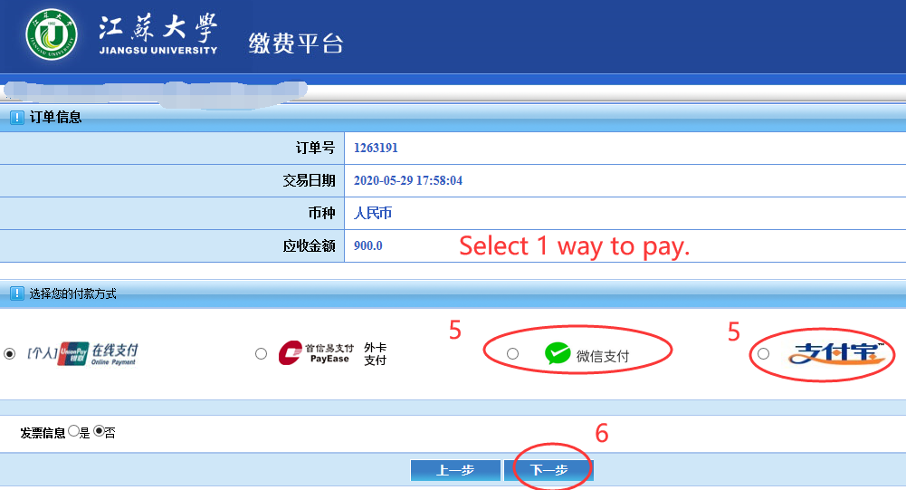

1. Check you have paid or not.

